Documentation for MDM for work
1-Add Device to MDM Console
2-Enrollment Process
4-Antitheft
4-Policy
Introduction
MDM for Work is basically a concept to separate the use of device for personal and professional use.
In Server side eScan MDM development code is divided in following projects
- Mwconsole.dll
- eServ.exe
- Updater.dll
Project paths for Mwconsole.dll

Module Name | Delphi Version | Project file | Ip Address | System Path | Vss Path | Vss user name &  Password
Mwconsole.dll | Delphi 7 | Mwconsole.dll | 192.168.2.222 | d:\SRC\ESCAN\DELPHISRC\MDM | - | N/A

eScan MDM includes :
- Server side development
- Coding part contains GUI, mwconsole.dll, eserv.exe,updater.dll.
- Apache configuration for httpd.exe (httpd.conf).
- Device side development (Android MDM For Work App)

1-Add Device to MDM console
To add device in MDM console server we have to select group in which we want add device and the select Add new device option from client action list.And then fill following information as (User Name,Mobile Number and email Id) and submit details to server.Then the mail will be sent to registered email id with enrollment details.

2-Enrollment Process

Enroll device with details sent to registered email id..If correct enrollment detail is provided then update enrolled device information to database.After successful enrollment a unique GCMID will be generated for each client device for MDM for work profile.Then after all the Antitheft action will be performed using assigned GCMID.

Server Side Enrollment Process
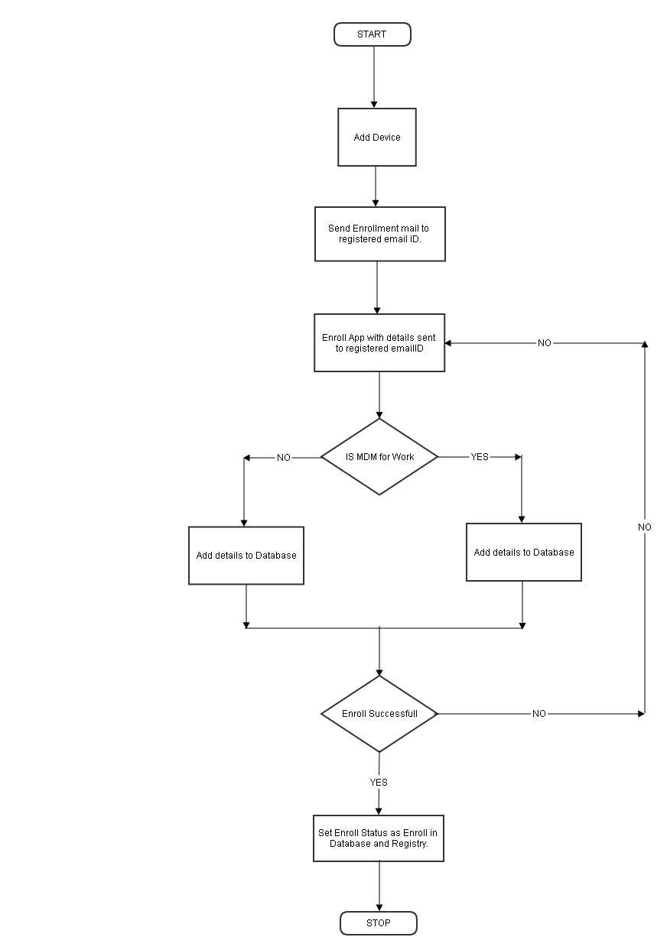
2-Antitheft in MDM for Work

Introduction:

Antitheft module is used in MDM for work to find the lost mobile device. If user has lost his device then he can find that device with the help of antitheft features. He can also perform some actions on his mobile device like wipe the data.

Functionality:
In antitheft we can see all the groups created by user and when we click on any group then all the list of mobile devices will be shown at right hand side table. In that table we can see the User name, Mobile number, Last Location, Last Wipe Status, Last Scream Status, Locked Status and Last Send Message Status.

There are two types of actions that we can perform on selected devices. We can select multiple devices using checkbox.
The actions are as following:
(1) Wipe (MDM for Work):
When we perform this action by click Wipe button for selected devices then all the important data of work profile will be deleted from the client device automatically.

(1) Remove Work Profile (MDM for Work):
When we perform this action by click Remove Work Profile button for selected devices then the work profile will be deleted from the client device automatically.

Antitheft Command Server Side Flow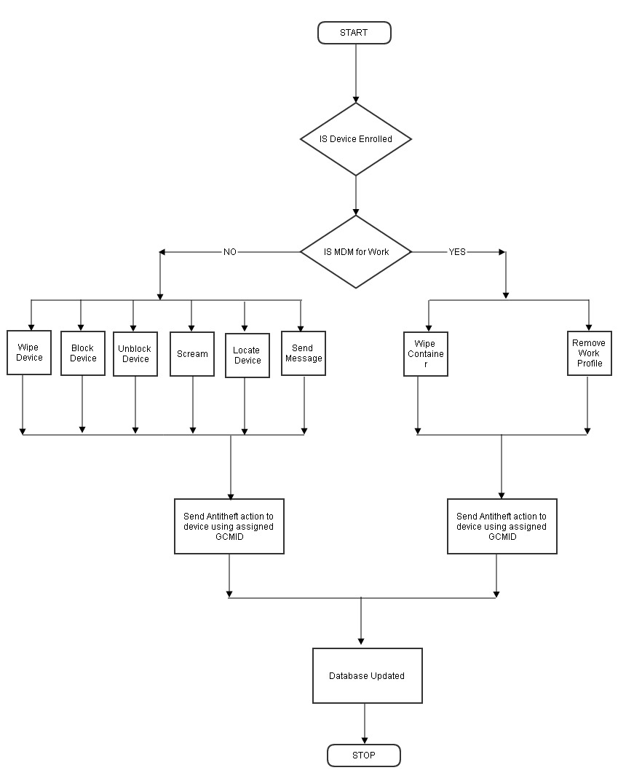
4-Policy for MDM for Work

Policy in MDM for work will be configured same as eScan MDM policy with some additional policy configuration.And client device ( MDM for work ) will read only the required policy details from the configured policy file.
Server Side Policy Flow

